Flower Pot Avenue
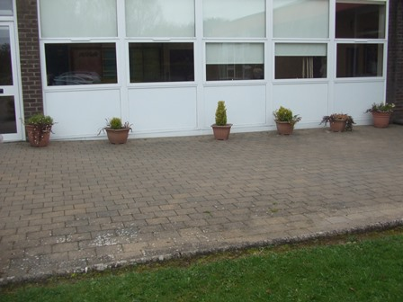
1 How many flower pots can you count? ____

2 Is your answer an odd or even number? ____

3 How many more sections of glass in the windows are there than flower pots?

Vegetable Plot
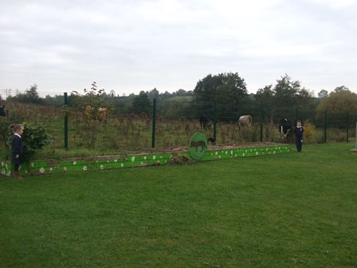
1 Use your foot span to measure how many steps it takes to get from one side of the vegetable plot to the other. ___ ____ ____ ____
2 Did you all get the same answer? Discuss why.

3 What is the least number of giant strides you can do to get to the other side? ___ ____ ____ ____
Building Blocks

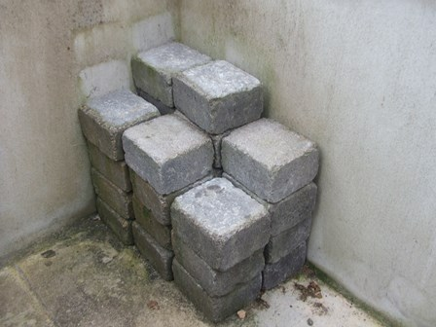
1 What 3D shape are the blocks? __________

2 How many rows of 4 blocks are there? _____

3 Can you work out how many blocks are there altogether? _______________

Clothes Bank
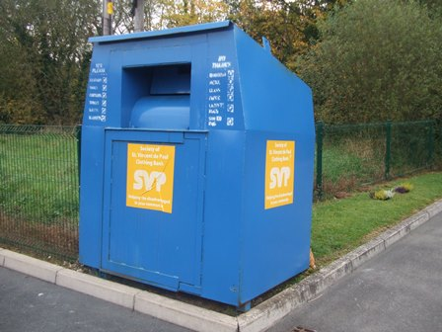
1 How many sides does the clothes bank have?
____________

2 How many corners does it have?
____________

3 How many squares can you find on it?
____________
Bird Table
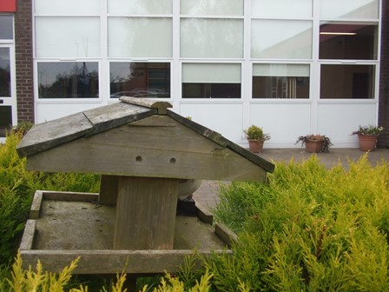
1 How many circles can you find on it?
_____________________
2 How many hand spans high is it?
______ ______ _______ ______
3 Using the statue of the bird work out how many birds could fit on the table.
____________

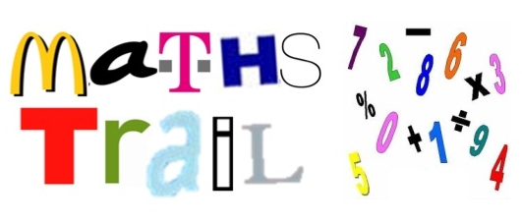
Names: ______
______________________________

